TASK 3

Напишите скрипт для суммы OrderQty для каждого года и зимних месяцев из Production.WorkOrder в виде транспонированной матрицы:

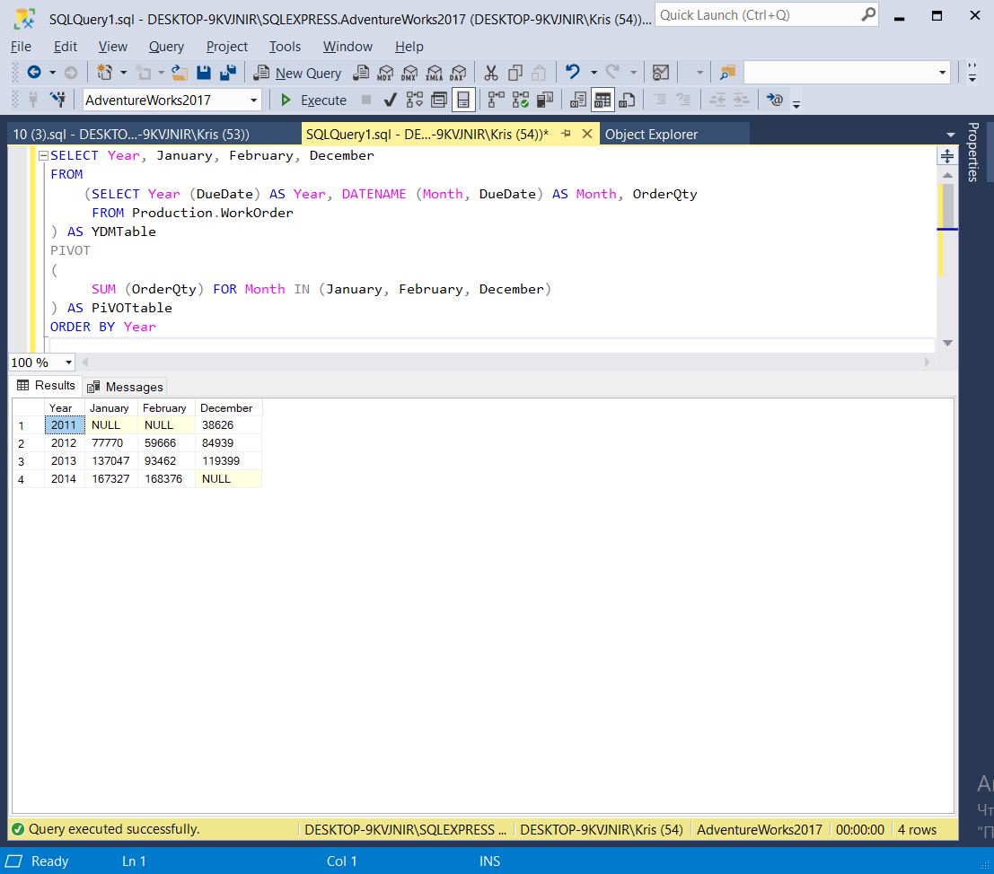

SELECT Year, January, February, December

FROM

(SELECT Year (DueDate) AS Year, DATENAME (Month, DueDate) AS Month, OrderQty

FROM Production.WorkOrder

) AS YDMTable

PIVOT

(

SUM (OrderQty) FOR Month IN (January, February, December)

) AS PiVOTtable

ORDER BY Year